Power Generation from Bus Seat Vibration
https://www.youtube.com/watch?v=38h--oy07bg

This project presents a novel approach to energy harvesting by utilizing mechanical vibrations generated from bus seat movements. The system employs piezoelectric sensor plates that convert mechanical stress and vibrations into electrical energy based on the piezoelectric effect. Since the output from the piezo sensors is alternating in nature, it is conditioned and directed to a charging module built around the TP4056 lithium battery charger, which stores the harvested energy in a 3.7V Li-ion battery.
An STM32 microcontroller is integrated into the system to monitor, process, and manage the generated power. It receives input signals from the piezoelectric sensors and power supply sources, enabling efficient control and system optimization. The stored energy is utilized for low-power applications such as mobile charging through a controlled switching mechanism. Additionally, an LCD display interfaced via an LCD driver provides real-time information about voltage levels, power generation, and system status.
The proposed system offers a sustainable and eco-friendly solution for generating renewable energy from every day public transportation systems. It reduces dependency on conventional energy sources and demonstrates the feasibility of implementing vibration-based energy harvesting in practical environments such as buses and other moving vehicles.

Major Objectives of this project:

• To design and develop a system that converts mechanical vibrations from bus seats into electrical energy using piezoelectric sensors.
• To implement an efficient energy harvesting mechanism by converting the generated alternating current (AC) from piezoelectric plates into usable direct current (DC).
• To store the harvested energy in a rechargeable 3.7V lithium-ion battery using a suitable charging module.
• To utilize an STM32 microcontroller for monitoring, controlling, and optimizing the power generation and distribution process.
• To develop a mobile charging unit powered by the harvested energy for low-power electronic devices.
• To display real-time system parameters such as voltage, power generation, and battery status using an LCD display.
• To create an eco-friendly and cost-effective solution for renewable energy generation in public transportation systems.
• To analyze the feasibility and efficiency of vibration-based energy harvesting in real-world conditions.
• To reduce dependency on conventional power sources by utilizing wasted mechanical energy.
• To promote sustainable and smart energy solutions in modern transportation systems.

Major blocks present in this system:
- Adapter power supply.
- 3.7v Li-ION Battery
- STM32 Micro controller
- Piezo sensors plate.
- Tp4056 module.
- LCD display
- Rectifier.
- Mobile charger.

Software’s used:
- STM32CubeIDE.
- Express SCH for Circuit Design
Regulated power supply:
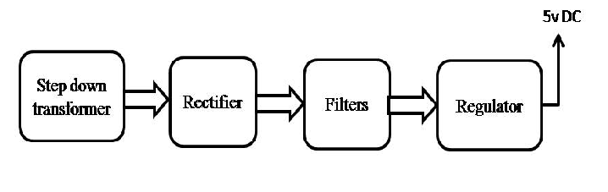
Block Diagram:

