Smart Helmet

The Smart Helmet System is an advanced safety solution designed to enhance rider protection by integrating real-time monitoring and vehicle control mechanisms. This project utilizes the Arduino Uno as the central controller to coordinate communication between the helmet unit and the vehicle ignition system.
The helmet section is equipped with multiple sensors, including Infrared (IR) sensors for helmet wearing detection and drowsiness monitoring, along with an MQ-3 Alcohol Sensor to detect alcohol consumption. These sensors continuously analyze the rider’s condition and transmit the data wirelessly using an RF transmitter.
On the vehicle side, an RF receiver captures the transmitted signals and forwards them to the Arduino controller. Based on the received data, the system makes intelligent decisions to either allow or restrict the vehicle ignition using a relay module. The ignition will only be enabled if the rider is wearing the helmet, is not under the influence of alcohol, and is alert. An LCD display provides real-time status updates, while a buzzer alerts the rider in case of unsafe conditions.
This system significantly reduces the risk of accidents caused by negligence, intoxication, and drowsiness. It demonstrates an effective integration of embedded systems, wireless communication, and sensor technology to promote road safety and responsible driving behaviour.

The main object of this project:

• Ensure the rider wears the helmet before starting the vehicle.
• Detect alcohol using MQ-3 Alcohol Sensor.
• Monitor drowsiness of the rider.
• Send data wirelessly using RF communication.
• Control ignition using Arduino Uno and relay.
• Provide alerts using buzzer and display status on LCD.
• Reduce road accidents and improve safety.

The major building blocks of this project are:

Helmet Side:

- Arduino UNO
- RF Transmitter
- IR Sensor - 2 (one for wear detection and another for drowsiness detection)
- MQ-3 Sensor
- Buzzer
Bike Section:
- Arduino UNO
- RF Receiver -
- 16x2 LCD Display
- Relay Module
- Ignition Control.

Software’s used:

- ARDUINO IDE STUDIO compiler for Embedded C programming.
- Express SCH for Circuit design.

Regulated power supply:
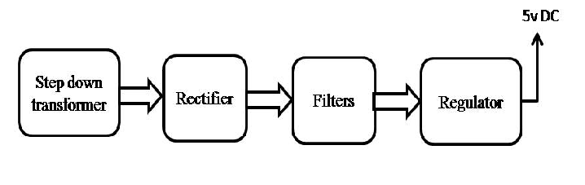

Block Diagram:
