Smart Dustbin

As people are getting smarter so are the things. While the thought comes up for Smart cities there is a requirement for Smart waste management. The idea of Smart Dustbin is for the Smart buildings, Colleges, Hospitals and Bus stands. The Smart Dustbin thus thought is an improvement of normal dustbin by elevating it to be smart using sensors and logics. Smart dustbins are a new idea of implementation which makes a normal dustbin smart using ultrasonic sensors for hand detection so based on that servo motor open/close the cap of dustbin and IR sensor for garbage level detection from the surface of the dustbin and give the audible alerts to the user if the dustbin is full.
ATMEGA328 microcontroller is a small computer on a single integrated circuit consisting of a relatively simple CPU combined with support functions such as a crystal oscillator, timers, and watchdog timer, serial and analog I/O etc. Microcontrollers are also used in scientific, high technology, and aerospace projects. Microcontrollers are designed for small or dedicated applications.
The project aims in designing a smart dust bin which is able to detect the dust levels from the surface of the dustbin and give the buzzer alert if the dustbin is full and which is able to detect the hand and based on that it will open/close the cap. The main controlling device of the project is PIC Microcontroller which is loaded program written in embedded C language.

The project provides learning’s on the following advancements:

- Designing of ATMEGA328 Controller-based sensors interfacing.
- Conversion of AC supply to DC supply.
- Atmega328 microcontroller working principle.
- Ultrasonic sensor working.
- IR sensor working.
5. Servo motor interfacing to the microcontroller.

The major building blocks of this project are:

- Regulated Power Supply.
- Atmega328 microcontroller.
- Reset button
- Crystal oscillator
- IR sensor.
- Ultrasonic sensor
- Servo motor.
- Buzzer

Software’s used:

- Embedded C programming.
- ARDUINO IDE programmer for dumping code into Micro controller.
- Express SCH for Circuit design.

Regulated Power Supply:

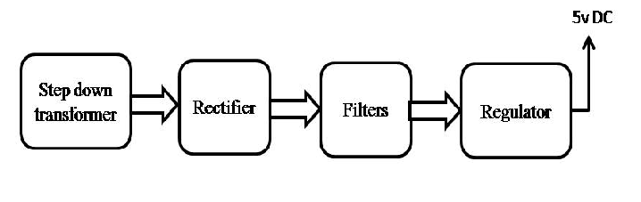

Block Diagram:

