Advanced User Controlled Roof Top Antenna Signal Tracking System with Geared DC Motor
https://www.youtube.com/watch?v=qDOCD0dSygk

The Advanced User Controlled Roof Top Antenna Signal Tracking System with Geared DC Motor is designed to improve television and wireless signal reception by automatically aligning a rooftop antenna toward the strongest signal source. The system uses a PIC microcontroller as the main control unit and employs IR transmitter and IR receiver modules for signal detection and tracking. Based on the received signal strength, the microcontroller controls a geared DC motor through a motor driver circuit to rotate the antenna in the desired direction for optimal signal reception.
The system also incorporates an LCD display to provide real-time status information, LED indicators for operational monitoring. A regulated power supply ensures stable operation of all components. This project reduces the need for manual antenna adjustment, improves signal quality, and provides a reliable, user-friendly solution for rooftop antenna positioning and tracking applications.

Main features of this project:

• Automatic antenna alignment for maximum signal reception.
• PIC microcontroller-based intelligent control system.
• Geared DC motor for precise antenna rotation and positioning.
• IR transmitter and receiver for signal tracking and control.
• Real-time antenna status display on LCD screen.
• LED indicators for system operation and signal status.
• User-controlled antenna positioning capability.
• Stable operation using a regulated power supply.
• Reduces manual effort and improves signal quality.
• Compact, reliable, and low-power design.
• Suitable for TV, radio, and wireless communication antenna applications.

Major blocks present in this project:
- Regulated Power supply.
- PIC microcontroller.
- LCD display.
- DC Motors with L283d.
- IR T x.
- IR Rx.
- Antenna Arrangement.
- Crystal Oscillator.
- Reset Button.
- LED indicator.
Software’s used in this project:
- PIC Compiler for Programming.
- Express SCH for Circuit design.

Regulated power supply:
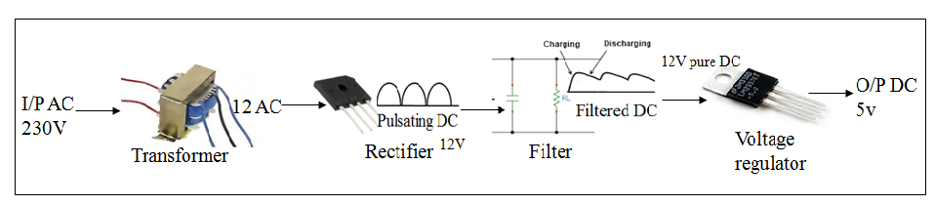

Block Diagram:
