EARLY FLOOD DETECTION WITH IOT &SMS
https://www.youtube.com/watch?v=mfO-4qKjWEA

Flooding is an unavoidable natural disaster that can cause heavy water flow, severe damage to properties, and loss of human life. The proposed IoT and GSM-Based Flood Detection and Automatic Dam Gate Control System is designed to continuously monitor water level and environmental conditions in dams and residential areas and provide early warnings during abnormal conditions. The system uses an Arduino UNO as the main controlling device, interfaced with an SR04 ultrasonic sensor to measure the distance from the sensor to the water surface, a water level sensor to detect the water level, a water flow sensor to monitor the flow rate, and a DHT11 sensor to measure temperature and humidity. A DC motor with a motor driver is used to control the dam gate automatically. The system continuously collects sensor data and displays the real-time status on an LCD while transmitting the data to the IoT cloud platform through an ESP8266 Wi-Fi module. When the water level, flow rate, or other monitored parameters exceed their predefined threshold values, the system activates an automatic dam gate-opening mechanism, provides an alert through the Wi-Fi connection, and sends an SMS notification to the respective authorities using a GSM module. By continuously monitoring water level and flow conditions, the proposed system provides early flood warnings, supports timely decision-making, and helps reduce the damage caused by sudden flooding. The system can also be enhanced with data analysis and prediction techniques to estimate the possibility of flooding before critical water levels are reached.

The main objectives of the project are:
- The main objective of this project is to detect the rising water level in a river/ lake from a reasonable distance and intimate that to the respective authorities through Internet and GSM. And also, the system opens the dame gets automatically if the flood level is high.

The major building blocks of this project are:
- Adapter Power Supply
- Arduino uno.
- Sr04 ultrasonic sensor.
- Water level sensor.
- Water flow sensor.
- DHT11 sensor.
- ESP8266 WI-FI MODULE.
- LCD display.
- GSM.
- DC MOTOR along with driver.

Software’s used:
- Embedded C programming.
- Arduino IDE studio for dumping code into Micro controller.
- Express SCH for Circuit design.

Regulated Power Supply:
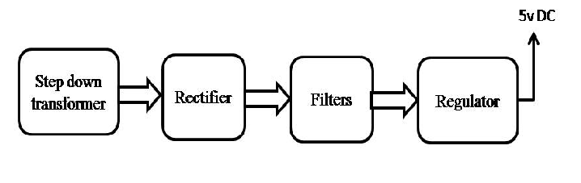

Block diagram of the project:
