Microcontroller Based Borewell Vehicle Status Informer Using GSM
https://www.youtube.com/watch?v=EdaGRgXLOUQ

The main aim objective of this project is to design an automatic borewell vehicle status informer using Arduino microcontroller which can be used for monitoring the number of borewell rods drilled and compressor runtime along with the location of the borewell vehicle.

The controlling device of the whole system is Arduino microcontroller. The number of borewell rods drilled into ground and unloaded from ground is calculated using proximity sensors. The location of borewell machine is monitored using GPS. The Compressor runtime is noted from the GPS Module. As soon as the compressor is switched ON, an SMS is forwarded to the borewell owner and the customer, along with its location and time. When the drilling process is over the number of rods drilled and total runtime of compressor is sent to owner and customer. An SMS is sent with the help of GSM module. All this process is controlled with the assist of Microcontroller. The status of the project will display on LCD. The microcontroller is programmed using Arduino IDE software.

Objectives
- To develop an automatic borewell vehicle status monitoring system using an Arduino microcontroller.
- To automatically count the number of borewell rods drilled and unloaded using proximity sensors.
- To monitor the location of the borewell vehicle using a GPS module.
- To record and monitor the compressor operating runtime during the drilling process.
- To send the vehicle location, drilling time, and compressor status to the borewell owner and customer through GSM.
- To send the total number of rods drilled and compressor runtime after completion of the drilling process.
- To display the borewell drilling status and important parameters on an LCD.
- To automate the complete monitoring process using an Arduino programmed through Arduino IDE.
- To improve transparency, accuracy, and real-time monitoring of borewell drilling operations.

The major blocks of the project:
- Power Supply.
- Arduino microcontroller
- RPS
- Proximity sensors
- compressor
- Keypad
- GPS module
- GSM modem.
- LCD display.

Software’s used:
- Arduino IDE for compiling and dumping code into Microcontroller.
- Express SCH for Circuit design.

Regulated Power Supply:

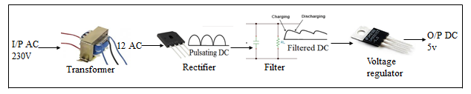
Block diagram:

