Integral Cycle Switching (Cycle Stealing) means of Power Control without Generating Harmonics
https://youtu.be/TIVn9e2uFDg

The project is designed to achieve integral cycle switching, a method to remove whole cycle, cycles or portions of cycles of an AC signal. It is a well-known and old method of controlling AC power, especially across linear loads such as heaters used in electric furnace.
In place of a linear load to be used in the output, a series motor or lamp can be used to verify the output. One side effect of utilizing this scheme is an imbalance in the input current or voltage waveform as the cycles are switched on and off across the load.
In this project we are using comparator for zero crossing detection which is fed as an interrupt to microcontroller. Here the microcontroller delivers the output based on the interrupt received as the reference for generating triggering pulses. Using these pulses, we drive the opto-isolators for triggering the TRIAC to achieve integral cycle control as per the input switches interfaced to the microcontroller. A lamp is provided in this project in place of a motor for demonstration purpose.

The main objectives of the project are:
1. Aims at energy conservation.
2. Provides fast access to through switches.
3. Device enable with zero crossing detector.

The main blocks of this project are:
• Micro controller (16F72)
• Reset button
• Crystal oscillator
• Regulated power supply (RPS)
• Led indicator
• Control buttons
• TRIAC
• LCD display.

Software’s used:
- PIC C compiling and dumping code into Microcontroller
- Express SCH for Circuit design.
- Proteus for hardware simulation.

Regulated Power Supply:
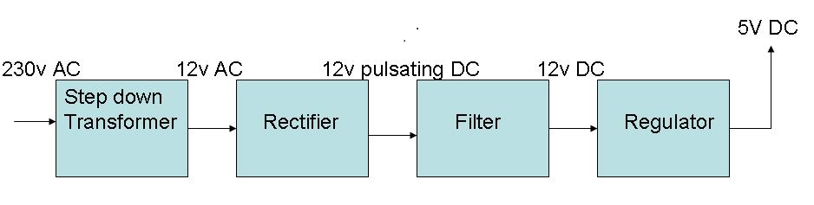

Block Diagram:

