Applying Wireless Sensor Network for Power Consumption Monitoring
https://www.youtube.com/watch?v=OyOfZZsuKdY

The main aim of this project is to develop a Wireless Sensor Network (WSN)-based power consumption monitoring system that enables real-time monitoring of electrical energy usage and wireless transmission of consumption data to a remote computer. The system uses an energy meter to measure power consumption, and the meter pulses are isolated through an optocoupler before being processed by a PIC microcontroller. The microcontroller calculates the energy consumed and displays the readings on an LCD through an LCD driver circuit. The measured data is transmitted wirelessly using a Zigbee transmitter module, while a Zigbee receiver connected to a PC or laptop through a USB-TTL interface receives and displays the data for monitoring and analysis. A crystal oscillator provides accurate timing for the microcontroller, and a regulated power supply ensures stable operation of the entire system. The proposed system offers low-cost, reliable, and energy-efficient remote monitoring of power consumption, making it suitable for homes, industries, commercial buildings, and smart energy management applications. By eliminating the need for manual meter reading and enabling wireless data collection, the system improves monitoring efficiency, reduces operational effort, and supports better energy management and conservation.

Features of this project:
- Wireless power consumption monitoring using Zigbee communication.
- Real-time energy usage measurement through an energy meter.
- PIC microcontroller-based data processing and control.
- LCD display for instant local viewing of power consumption data.
- Remote monitoring on a PC/Laptop through a Zigbee receiver and USB-TTL interface.

Major blocks present in this project:
- Regulated power supply.
- PIC Microcontroller.
- LCD display.
- Energy meter.
- Optocoupler.
- Zigbee transmitter.
- Zigbee receiver.
- USB TTL.
- AC Bulb.

Software’s used in this project:
1. PIC-C compiler for Embedded C programming.
2. PIC kit 2 programmer for dumping code into Micro controller.
3. Express SCH for Circuit design.
Regulated power supply:

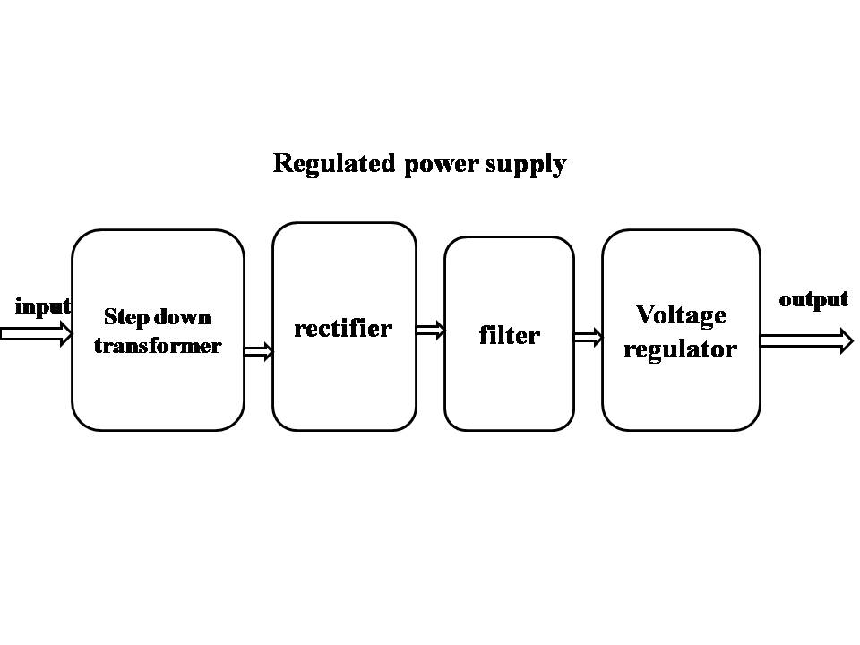
Block Diagram:
