A Novel Technique of Ac Power Control Using Micro Controller Based Inverter
https://www.youtube.com/watch?v=R6eGn7LFYcQ

The main aim of this project is to design and implement a microcontroller-based inverter system for efficient AC power control. The system converts a 12V DC input into a controlled AC output using a PIC microcontroller, MOSFET switching devices, and a step-up transformer. The PIC microcontroller generates switching pulses that drive the MOSFETs through a driver IC, producing an alternating waveform. A crystal oscillator provides accurate timing for the microcontroller, while a regulated power supply ensures stable operation of the control circuit. The generated AC signal is stepped up through a transformer to provide the required voltage for operating AC loads. The proposed technique offers improved power control, higher efficiency, and better reliability compared with conventional inverter circuits. The system is suitable for domestic backup power, small industrial applications, renewable energy systems, and other low-cost inverter-based power conversion applications. By using a programmable microcontroller, the inverter output can be controlled accurately, resulting in stable AC power delivery and efficient utilization of available energy.

Features of this project:
• PIC microcontroller-based inverter control for accurate switching.
• Converts 12V DC to AC output using a step-up transformer.
• MOSFET-based power switching for high efficiency.
• Stable output frequency using a crystal oscillator.
• Regulated power supply for reliable circuit operation.
• Low-cost and compact design.
• High efficiency with reduced power loss.
• Suitable for various AC loads and backup power applications.

Major blocks present in this project:
- Regulated power supply
- Micro controller
- Inverter.
- IC.
- Battery.
- Step UP Transformer.
- AC Bulb.

Regulated Power Supply:
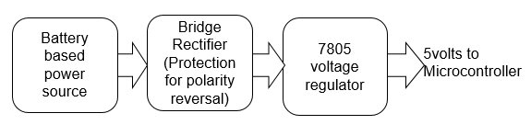

Block Diagram:
