Remote Control System of Smart Appliances Based on Wireless
https://youtu.be/Ug9KIXOhTIQ

The project aim is to design a device controlling system through android smart phone through Bluetooth. The devices can be controlled wirelessly using zigbee technology.
Bluetooth is an open standard specification for a radio frequency (RF)-based, short-range connectivity technology that promises to change the face of computing and wireless communication. It is designed to be an inexpensive, wireless networking system for all classes of portable devices, such as laptops, PDAs (personal digital assistants), and mobile phones.
Zigbee is a PAN technology based on the IEEE 802.15.4 standard. Unlike Bluetooth or wireless USB devices, Zigbee devices have the ability to form a mesh network between nodes. Meshing is a type of daisy chaining from one device to another. This technique allows the short range of an individual node to be expanded and multiplied, covering a much larger area.
Traditional household internal control network is generally implemented through wiring. This method is not only troublesome but also has poor scalability. Wireless network technology becomes new trends with its simple and convenient networking. ZigBee technology characterizes good security, high reliability, low cost, low power consumption, large network capacity. With these features, Zig Bee is widely used in smart home system.
Features of this project:
- Using Bluetooth technology.
- Using Zigbee technology.
- Remote control of electrical appliances.
Software’s used:
- PIC-C compiler for Embedded C programming.
- PIC kit 2 programmer for dumping code into Micro controller.
- Express SCH for Circuit design.

Major blocks present in this system
- Regulated power supply.
- PIC Micro controller.
- HC-05 Bluetooth TX, RX tooth Module.
- ZIGBEE.
- Crystal oscillator.
- Reset.
- LED indicator.
Regulated power supply:
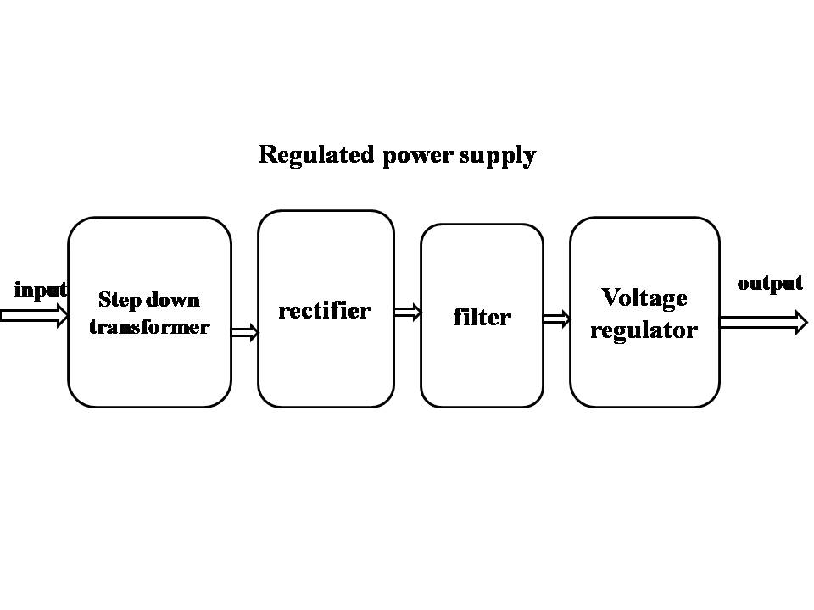

Block Diagram:
