SOLAR-BASED-COOL-CAP

https://youtu.be/OElFzBXkd50

Solar panels (arrays of photovoltaic cells) make use of renewable energy from the sun, and are a clean and environmentally sound means of collecting solar energy. The Solar Cooling Fan Caps are specially designed for summer tourists as well as fishing and climbing mountains, playing golf, sport meeting, people working outdoors and children. It’s good for preventing sunstroke and lowering the temperature and they make great gifts. There is a solar cell in front of the cap. The solar cell can transfer solar energy directly into electric power which can turn on the fan. Its fanning can change automatically depending on the availability of sunlight. Wear these caps during the hot summer and you can enjoy a cool, gentle and agreeable breeze. The solar Fan Cap offers you a pleasant cool world to accompany you in your summer activities. The novel design of our solar Fan Caps is fun for kids of all ages.
In this project Solar panel of 3V is used and a rechargeable battery is provided to store the energy. An ON /OFF switch is provided for user-controlled operation. The uniqueness of this project is, the cap can sense the intensity of the sun light temperature and automatically switches on the cooling fan without user’s interference. A temperature sensor is used to detect the hotness intensity of the atmosphere. The user can set the temperature value, at where he wants to switch ON the cooling fan, by adjusting a preset.

Main features of this project:
- Clean and user friendly.
- Preventing sunstroke.
- Solar Fan Cap offers you a pleasant cool world.

Main blocks present in this project:
- Solar panel
- Regulated power supply
- ON/OFF Control
- Temperature sensor
- Transistorized dc fan driver
- Cooling fan

Regulated power supply:

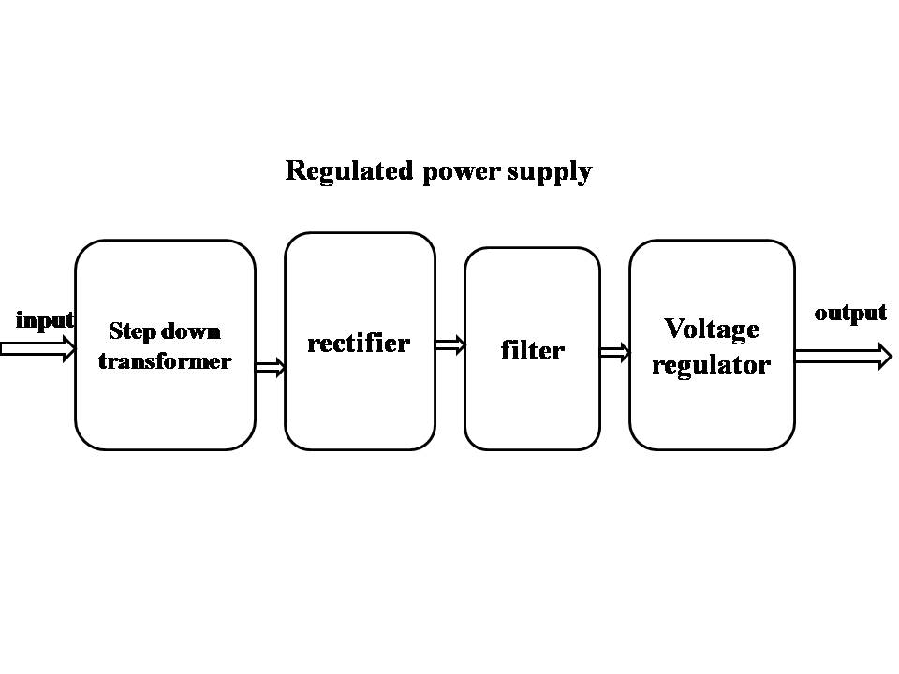

Block Diagram:

