Three phase Transmission Line Fault Detection and Alert. Line - Line & Line - Ground with distance
https://www.youtube.com/watch?v=HJU4I9kLeMg

The main aim of this project is to design and implement a Three-Phase Transmission Line Fault Detection System using an Arduino UNO. The system is capable of detecting different types of faults occurring in a three-phase transmission line, such as Line-to-Line (L-L) faults, Line-to-Ground (L-G) faults. The detected fault type and its location in KM are displayed on an LCD module for easy monitoring.
The proposed system is based on Ohm's Law, which is used to determine the fault location accurately and cost-effectively. Current sensing circuits consisting of resistor networks are connected to the Analog-to-Digital Converter (ADC) ports of the Arduino UNO. These circuits provide voltage values corresponding to different cable lengths, enabling the microcontroller to identify the fault location in kilometres.
Faults are created manually at predefined distances along the transmission line model. When a fault occurs, the Arduino processes the sensor data, identifies the fault type and location, and displays the information on the LCD screen. Simultaneously, a buzzer is activated to alert the user. The system also trips the affected phase through a relay, and the corresponding phase status is indicated using bulbs.
The Arduino UNO serves as the main controlling unit, executing a program developed in Embedded C language. The proposed system provides a simple, reliable, fast, and economical solution for transmission line fault detection, helping maintenance personnel quickly identify and rectify faults, thereby improving the reliability of power distribution systems.
Objectives:
- Design a three-phase fault detection system.
- It will detect line-line and line-ground faults.
- Alert fault indication using BUZZER.
- Display the fault type on LCD display.

The main blocks of this project are:
- Adapter power supply.
- Arduino UNO Microcontroller.
- Three-Phase Transmission Line.
- Line-to-Line Fault.
- Line-to-Ground.
- Resistor.
- Relays.
- LCD with driver.
- Buzzer.
- R Y B Bulbs.

Software’s Used:
- Arduino IDE studio compiler for dumping program.
- Express SCH for Circuit design.

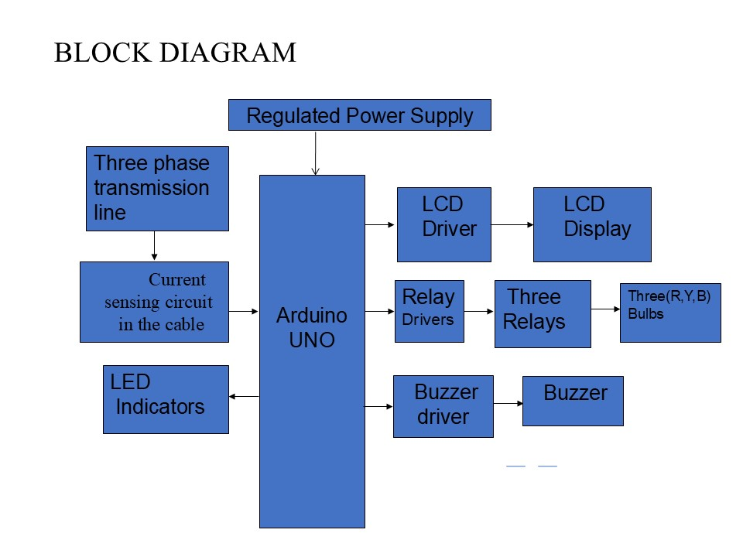
FIG 3.1: Block diagram of THREE PHASE TRANSMISSION LINE FAULT DETECTION

