Remote-Control System of High Efficiency and Intelligent Street Lighting Using a ZIGBEE Network of Devices and Sensors
https://www.youtube.com/watch?v=-gobcOxJj9o

The proposed remote-control system can optimize management and efficiency of street lighting systems. It uses ZigBee -based wireless devices which enable more efficient streetlamp-system management.
It uses an LDR, IR sensor combination to control and guarantee the desired system parameters; the information is transferred point by point using ZigBee transmitters and receivers and is sent to a control terminal (PC) used to check the state of the street lamps and to take appropriate measures in case of failure. If the system detects street light failure it will send the alert SMS to the respective authority through GSM.
If the street light is not stopped after the night, the loss will continue throughout the day. And also, the street light is not necessary when there are no human movements in the street. So, to come out of these disadvantages is introducing a ZIGBEE based street lighting system.
An application will be created for this particular system and by using this application the street light can be operated wirelessly by using ZIGBEE. Whenever the human movements will be occurred beyond the street light then the light will be automatically controlled. After the sunlight has been reduced in the street then the Street light will glow by using a light sensor. By using this project wastage of electricity will be reduced and human effect also reduced.
LDRs or Light Dependent Resistors are very useful especially in light/dark sensor circuits. Normally the resistance of an LDR is very high, sometimes as high as 1,000,000 ohms, but when they are illuminated with light, the resistance drops dramatically.
Thus in this project, LDR plays an important role in switching on the lights based on the intensity of light i.e., if the intensity of light is more (during daytime) the lights will be in off condition. And if the intensity of light is less (during nights), the lights will be switched ON.

Main features of this project:
- Wastage of electricity will be reduced.
- Human effect also reduced.

Major blocks present in this system:
- Regulated power supply.
- PIC Micro controller.
- IR Sensors.
- LDR Sensors.
- LCD display.
- Street Lights.
- Zigbee tx,rx.
- GSM.
- PC.
Regulated power supply:
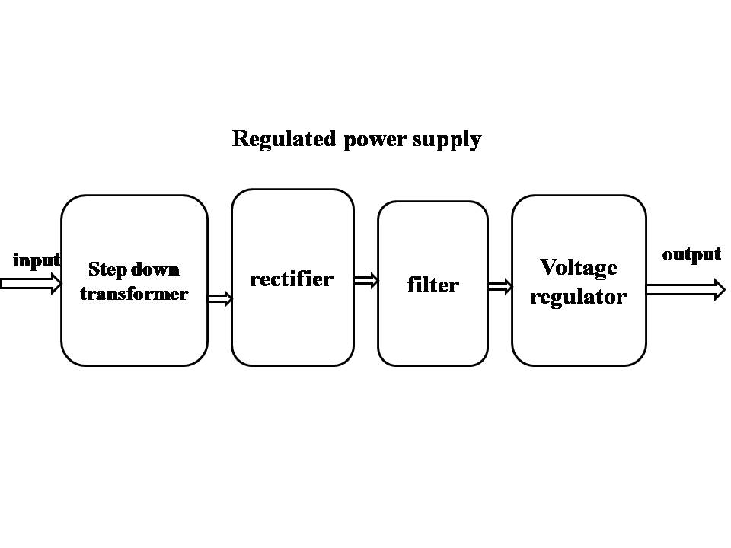

Block Diagram:

