Automated Dual-Axis Sun Tracking System for Optimal Solar Energy Capture
https://www.youtube.com/watch?v=kh3Nn2AVYxc

The project “Automated Dual-Axis Sun Tracking System for Optimal Solar Energy Capture” is designed to improve the efficiency of solar power generation by continuously tracking the position of the sun using a dual-axis tracking mechanism. The system uses LDR sensors to detect sunlight intensity and an Arduino Uno microcontroller to control servo motors that rotate the solar panel in both horizontal and vertical directions for maximum solar energy absorption throughout the day. An RTC module is interfaced through the I2C bus to provide accurate real-time operation and automated tracking control. By continuously adjusting the panel position according to the sun’s movement, the system increases power generation efficiency compared to fixed solar panels. This project provides an effective, eco-friendly, and reliable solution for renewable energy applications, especially in rural electrification and solar-powered systems.

The main objectives of this project:
- To design and develop a dual-axis solar tracking system for maximum solar energy capture.
- To increase the efficiency of solar power generation compared to fixed solar panels.
- To automatically track the sun’s movement using LDR sensors and servo motors.
- To control the solar panel movement using Arduino Uno microcontroller.
- To achieve continuous and accurate solar tracking in both horizontal and vertical directions.
- To reduce energy wastage and improve renewable energy utilization.
- To provide an eco-friendly and cost-effective solution for rural electrification.
- To implement real-time automated operation using RTC interfacing.
- To improve battery charging and overall system performance in solar applications.
- To promote the use of renewable energy systems for sustainable development.

The major building blocks of this project are:
- Regulated Power supply.
- Arduino UNO.
- Sun light Sensor to sense the sun direction.
- Motorized mechanism to control the position of solar panel.
- Servo motors
- RTC clock
- LED indicator.

Software’s used:
- ARDUINO IDE STUDIO compiler for Embedded C programming.
- Express SCH for Circuit design.

Regulated power supply:
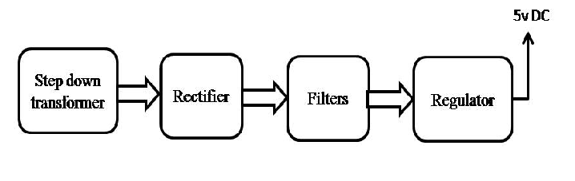
Block Diagram:

