An Integrated Dynamic Voltage Restorer-Ultracapacitor Design Improving Power Quality
https://www.youtube.com/watch?v=iCFI2xR0gsk
UCAP (Ultracapacitors) is integrated into dc-link of the DVR (Dynamic voltage restorer) through a bidirectional dc–dc converter, which helps in providing a stiff DC-link voltage, and the integrated UCAP-DVR system helps in compensating temporary voltage sags and voltage swells, which last from 3 s to 1 min.
Complexities involved in the design and control of both the dc–ac inverter and the dc–dc converter are discussed. The overall system is developed and compared to the experimental hardware setup.
A multiple-output buck/boost dc-dc converter with average-current control is presented in this paper. With the proposed duty-cycle and control-current predictor, fast and robust reference tracking of inductor current is achieved. So, in this project, we make use of an onboard computer, which is commonly termed as micro controller. It acts as heart of the project. This onboard computer can efficiently communicate with the output and input modules which are being used.
Objective of Proposed System:
The objective of the integrated UCAPDVR system with active power capability is to compensate for temporary voltage sag (0.1–0.9 p.u.) and voltage swell (1.1–1.2 p.u.), which last from 3 s to 1 min
The major building blocks of this project are:
- Regulated power supply.
- PIC Micro controller.
- Rechargeable battery.
- POT.
- Relays.
- AC Lamp.
- Inverter.
- LED indicator
- Crystal oscillator.
- Reset Button.

Software’s used in this project:
- PIC Compiler for Programming.
- Express SCH for Circuit design.

Regulated power supply:
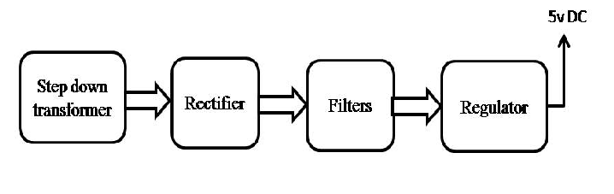

Block Diagram:
