Piezoelectric Based Power Generation using Clutch and Braking System
https://www.youtube.com/watch?v=-SFqc57fmzk

Energy harvesting from mechanical motion is an effective approach to generate power for low-energy electronic applications. This project, “Piezo Electric Power Generator by Accelerator Clutch,” focuses on generating electrical energy using piezoelectric sensors mounted on an accelerator clutch mechanism. When pressure is applied to the clutch during vehicle operation, the piezoelectric plates convert mechanical stress into electrical energy.
The generated voltage is conditioned using a charge controller and battery charging circuit, allowing the harvested energy to be stored and utilized for applications such as mobile charging. A voltage sensor continuously monitors the generated output and sends the data to an Arduino UNO microcontroller. The microcontroller processes this information and displays the generated voltage on an LCD through an LCD driver circuit. LED indicators provide visual status indications, while a regulated power supply and crystal oscillator ensure stable system operation.
This system demonstrates an efficient method of utilizing otherwise wasted mechanical energy and highlights the potential of piezoelectric technology for sustainable and renewable power generation in automotive and portable electronic applications.

Objectives:
• To design and develop a piezoelectric power generation system using an accelerator clutch mechanism.
• To convert mechanical pressure applied on the accelerator clutch into electrical energy using piezoelectric sensors.
• To measure the generated voltage using a voltage sensor and process the data through an Arduino UNO microcontroller.
• To display the generated voltage in real time on an LCD for monitoring purposes.
• To store the generated electrical energy using a battery charging circuit.
• To utilize the stored energy for low-power applications such as mobile charging.
• To demonstrate efficient utilization of wasted mechanical energy for renewable energy generation.
• To study the feasibility of piezoelectric energy harvesting in automotive applications.

Major blocks present in this system:
- Regulated power supply.
- Arduino UNO Micro controller.
- Piezo sensors.
- Charging circuit
- LCD Display.
- Mobile charger.
- Accelerator Clutch.

Software’s used:
- Embedded C programming.
- Arduino UNO programmer for dumping code into Microcontroller.
- Express SCH for Circuit design.

Regulated power supply:
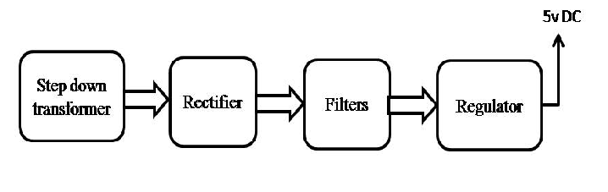
Block diagram:

