A design of highly sensitive Alcohol sensor with auto car ignition disable feature using Micro controller

The main Aim of this project is to develop a system that can detect the alcohol content in the air exhaled by the driver and automatically turn off the car if Alcohol percentage exceeds the limit.
According to a survey done by W.H.O Almost every 90 seconds, a person is injured in a drunken driving crash.. Because of Drunk and Drive the people are highly injured or sometimes dead. This is killing not only the driver but also the co-passengers travelling on the road at the same time. .In order to overcome this problem scientist’s proposed a project “High Sensitive Alcohol sensor with Auto car Ignition Disable Function”.
In this project we are using micro controller. In this we are going to embedded the program to receive data from alcohol sensor, convert it into digital form and then control the ignition system. Alcohol sensor gives out analog data that can’t be analyzed by 8051 so we use analog to digital converter to convert it in to digital format. After that the data is stored and then compared to threshold values if the value is beyond its limits then controller takes appropriate action. Here in this project we are going to turn OFF the ignition system, by doing so we can stop the car and prevent accidents that occur due to drink and drive. Here we can use Triacs or electro mechanical relays to control the ignition system.
Main Features of this project:
- Automatically turn off the car if Alcohol percentage exceeds the limit.

Major blocks present in this project:

- Regulated power supply
- Micro controller
- Alcohol sensor
- Relay driver
- Relay
- Ignition system
Software’s used in this project:
- PIC-C compiler for Embedded C programming.
- PIC kit 2 programmer for dumping code into Micro controller.
- Express SCH for Circuit design.
- Proteus for hardware simulation
Regulated power supply:
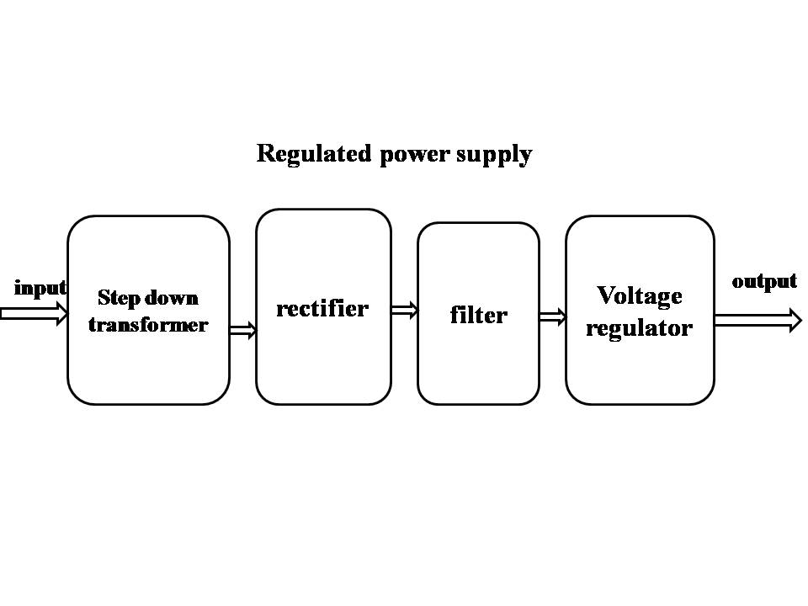

Block Diagram:
