Smart Helmet With Crash Detection And Emergency Alert

Road accidents are a major cause of fatalities worldwide, with delays in emergency response often resulting in the loss of lives. To address this challenge, this project proposes the development of a Smart Helmet with Crash Detection and Emergency Alert capabilities, designed to detect accidents in real time and automatically notify emergency contacts. The system is built around an Arduino Nano microcontroller, interfaced with an MPU6050 accelerometer to detect sudden impacts or abnormal movements that indicate a crash. A GPS module is used to determine the precise location of the incident, while a GSM module (SIM800L) transmits the accident alert along with the location coordinates to pre-registered emergency contacts via SMS. An LCD display is incorporated to provide real-time system status, and a buzzer generates immediate audible alerts to draw attention in the event of a crash. Powered by a rechargeable battery for portability and continuous operation, the helmet ensures reliability even during extended use. By integrating real-time crash detection with automated location sharing, this system aims to significantly reduce emergency response time, thereby improving the chances of survival and minimizing the consequences of road accidents.

The main object of this project:
• Detect road accidents in real time using an accelerometer.
• Automatically send the accident location to emergency contacts via GSM/GPS.
• Provide immediate local alerts through a buzzer and display system.

The major building blocks of this project are:

- Battery.
- ARDUINO NANO.
- MPU6050.
- GSM.
- GPS.
- LCD Display.
- Buzzer.

Software’s used:

- ARDUINO IDE STUDIO compiler for Embedded C programming.
- Express SCH for Circuit design.

Regulated power supply:
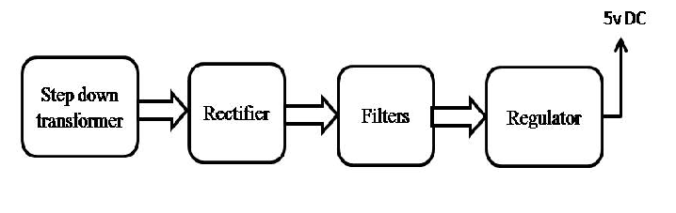

Block Diagram:

