Foot step power generation using piezo electric sensor
The main aim of the project is to generate power from renewable energy sources; system makes use of Piezo. The system monitors the parameters coming from the piezo sensor, energy from piezo sensor values displayed on the LCD. The energy from the piezo sensors is used to charge the mobile.
A piezoelectric sensor is a device that uses the piezoelectric effect, to measure changes in pressure, acceleration, temperature, strain, or force by converting them to an electrical charge. The prefix piezo- is Greek for 'press' or 'squeeze'.
The main controlling part of the whole system is Micro controller. In this project Piezo sensors, LCD are interfaced to micro controller section. Micro controller reads the values from the piezo sensors. Energy values displayed on the LCD which is interfaced with the controller unit. The energy from the sensors is stored by using battery, and it is helpful to charge the mobile.
Major features of this project:
- Efficient and low-cost design.
- Low power consumption.
Major blocks present in this system:
- Battery
- Micro controller
- Piezo sensors
- Charging circuit
- LCD

Software’s used:
- Arduino IDE
- Express SCH for Circuit Design
Regulated power supply:
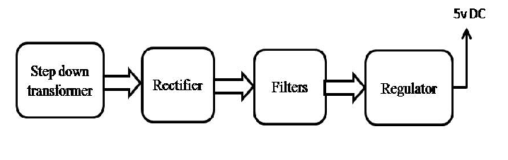
Block diagram:

