BLDC Motor Driven Solar PV Array Fed Water Pumping System Employing Zeta Converter

Drastic reduction in the cost of power electronic devices and annihilation of the fossil fuels in near future invite to use the solar photovoltaic (SPV) generated electrical energy for various applications as far as possible. Water pumping, a standalone application of the SPV array generated electricity is receiving wide attention now a days for irrigation in the fields, household applications and industrial usage.
A solar panel is a large flat rectangle, typically somewhere between the size of a radiator and the size of a door, made up of many individual solar energy collectors called solar cells covered with a protective sheet of glass. The cells, each of which is about the size of an adult's palm, are usually octagonal and colored bluish black. Just like the cells in a battery, the cells in a solar panel are designed to generate electricity; but where a battery's cells make electricity from chemicals, a solar panel's cells generate power by capturing sunlight instead. They are sometimes called photovoltaic cells because they use sunlight ("photo" comes from the Greek word for light) to make electricity (the word "voltaic" is a reference to electricity pioneer Alessandro Volta).

SOLAR BASED water pumping system with an incremental conductance (INC) MPPT algorithm is used to operate the zeta converter such that the SPV array always operates at its MPP and the BLDC motor experience a reduced current at the starting. A three-phase voltage source inverter (VSI) is operated by fundamental frequency switching for the electronic commutation of BLDC motor. The SPV array is designed such that the proposed system always exhibits satisfactory performance regardless of the solar irradiance level or its variation.

The main objectives of the project are:
- Belonging to the family of buck-boost converters, the zeta
- Converter can be operated either to increase or to decrease the output voltage.
- The aforementioned property also facilitates the soft starting of the BLDC motor unlike a boost converter which habitually stepup the voltage level at its output, not ensuring the soft starting.
- Unlike a simple buck-boost converter, the zeta converter has a continuous output current. The output inductor makes the current continuous and ripples free.
- reduces the complexity and probability of slow down the system response.

The project provides learning’s on the following advancements:

- Learning about solar panel.
- Learning about BLDC Motor.
- Conversion of DC supply to DC supply.
- Conversion of DC supply to AC supply.
- Embedded C programming.
- PCB designing.

The major building blocks of this project are:

- Solar Supply
- Zeta Converter
- Three Phase VSI
- BLDC Motor
- Isolation Circuit
- Gate Driver Circuit
- Buffer Circuit
- Micro-Controller Circuit
- Centrifugal Pump
Software’s used:
- PIC C compiling and dumping code into Microcontroller
- Express SCH for Circuit design.
- Proteus for hardware simulation.

Regulated Power Supply:
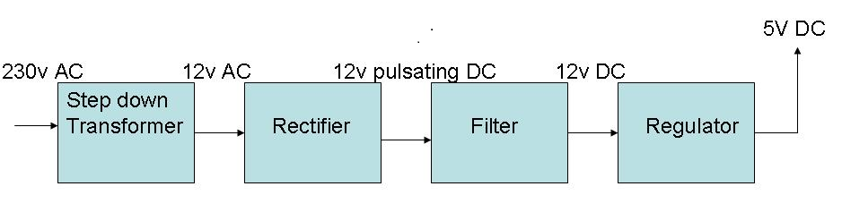

Block diagram:
