Electric Line Man Safety with Password Based Circuit Breaker
The project is designed to control a circuit breaker by using a password for the safety of electric man. Critical electrical accidents to line men are on the rise during electric line repair due to lack of communication and co-ordination between the maintenance staff and electric substation staff.
This proposed system provides a solution that ensures safety of maintenance staff, i.e., line man. The control to turn on/off the line will be maintained by the line man only because this system has an arrangement such that a password is required to operate the circuit breaker (on/off).
This system is fully controlled by a microcontroller. A matrix keypad is interfaced to the microcontroller to enter the password. The entered password is compared with the password stored in the ROM of the microcontroller.
If the password entered is correct, then only the line can be turned on/off. The activation / deactivation of the circuit breaker is indicated by a lamp that turns on or off.
Furthermore, this project in future can be enhanced by using EEPROM, for the user to change the password for more secured system interaction.
Main blocks used in the project:
- Regulated power supply.
- Microcontroller.
- Keypad.
- Relay driver.
- Relay.
- LED indicator.

Software’s used in the project are:
- PIC-C compiler for Embedded C programming.
- PIC kit 2 programmer for dumping code into Micro controller.
- Express SCH for Circuit design.
- Proteus for hardware simulation.

Regulated power supply:
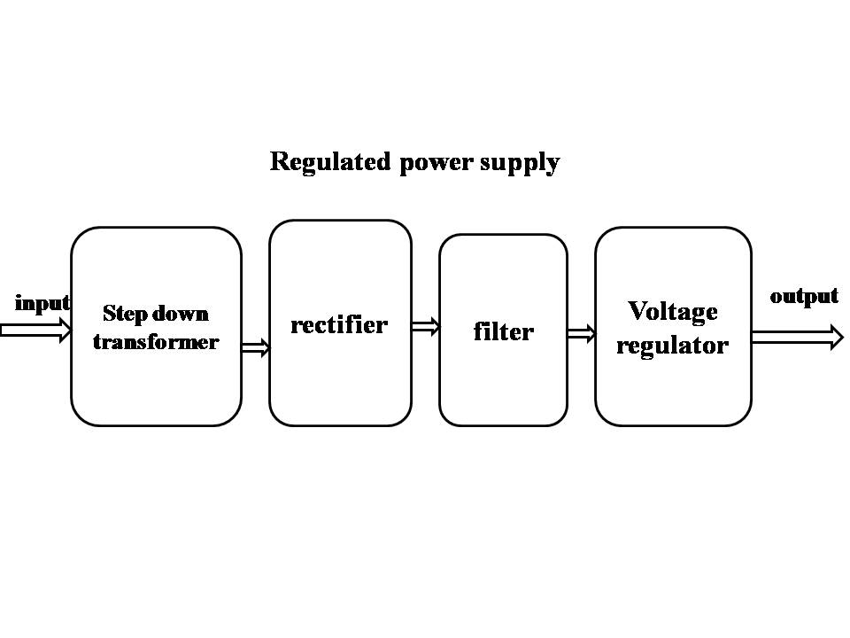

Block diagram:
