A New-Coupled-Inductor Circuit Breaker for DC Applications
In order to eliminate power conversion steps, future micro grids with renewable energy sources are being visualized as dc power systems. System components such as sources (solar panels, fuels cells, etc.) loads, and power conversion have been identified and are readily available. However, when it comes to dc circuit breakers, many designs are still in the experimental phase. The main limitation is that interrupting a current which does not have a zero crossing will sustain an arc.
This project introduces a new type of dc circuit breaker. It uses a short conduction path between the breaker and load as well as mutual coupling to automatically and rapidly switch OFF in response to a fault. The proposed breaker also can have a switch at the output so that it can be used as a DC switch.
The major building blocks of this project are:
- PIC Microcontroller.
- Regulated Power Supply.
- Two electrically isolated current sensors.
- Electromagnetic relay.
- Buzzer.
- LED Indicators.
- LCD display.

Software’s used:
- PIC-C compiler for Embedded C programming.
- PIC kit 2 programmer for dumping code into Micro controller.
- Express SCH for Circuit design.
- Proteus for hardware simulation.

Regulated Power Supply:

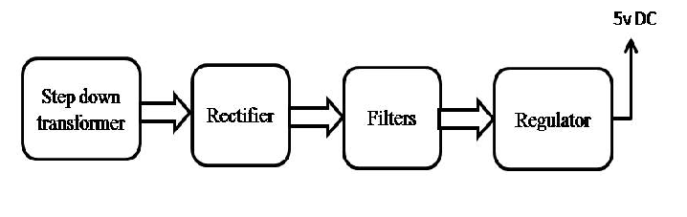Block Diagram:
