https://www.youtube.com/watch?v=Zd8W82ommL4
Foot step power generation using piezo electric sensor
The main aim of the project is to generate power from renewable energy sources; system makes use of Piezo. The system monitors the voltage coming from the piezo sensor, energy from piezo sensor values displayed on the LCD. The energy from the piezo sensors is used to charge the MOBILE battery.
A piezoelectric sensor is a device that uses the piezoelectric effect, to measure changes in pressure, acceleration, temperature, strain, or force by converting them to an electrical charge. The prefix piezo- is Greek for 'press' or 'squeeze'.
The main controlling part of the whole system is Micro controller. In this project Piezo plate along with voltage sensor, LCD are interfaced to micro controller section. Micro controller reads the voltage values from the piezo plate and will be display on the LCD
The energy from the piezo plate is stored into the rechargeable battery through charging circuit. Battery power is fed as input to the three USB port through TP4056IC for charging rechargeable lithium batteries using the constant-current/constant-voltage (CC/CV) charging method. In addition to safely charging a lithium battery the module also provides necessary protection required by lithium batteries.

Major features of this project:
- Electricity generation from piezo plates.
- Monitoring generated voltage on LCD module.
Major blocks present in this system:
- ARDUINO UNO Micro controller
- Piezo sensors.
- Rechargeable Battery.
- Voltage sensor.
- Charging circuit
- LCD display.
- Tp4056IC.
- USB port.

Software’s used:
- Arduino IDE
- Express SCH for Circuit Design
Regulated power supply:
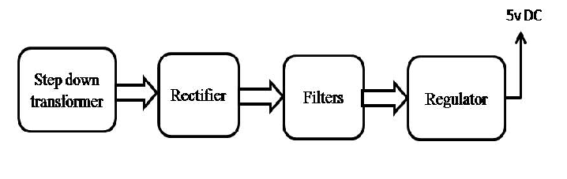
Block diagram:

