LI FI WATCH BABY SYSTEM USING ARDUINO

ABSTRACT
This project presents the design and implementation of a LiFi Watch Baby System, leveraging the Arduino platform. The system aims to provide real-time monitoring and alerts for infants in a nursery environment. Central to the system is an Arduino Uno microcontroller, which integrates with a DHT11 temperature and humidity sensor, a BH-17xx light sensor, LED lights for visual indicators, an LDR for ambient light detection, an ESP8266 WiFi module for wireless communication, and a buzzer for audible alerts.
The DHT11 sensor continuously monitors the ambient temperature and humidity levels, ensuring a comfortable environment for the baby. The BH-17xx light sensor measures the light intensity, adjusting the LED lights accordingly to provide optimal illumination without disturbing the baby. The LDR aids in detecting changes in ambient light levels, triggering alerts if sudden changes occur.
The ESP8266 WiFi module enables remote monitoring capabilities, allowing caregivers to monitor the baby's status via a mobile application. Real-time alerts are sent to the application if any parameters, such as temperature or light levels, exceed predefined thresholds or if the system detects any anomalies.
Overall, the proposed LiFi Watch Baby System offers a cost-effective and efficient solution for baby monitoring, ensuring the safety and well-being of infants in a nursery setting.
OBJECTIVES
1. Develop a system for real-time monitoring of nursery conditions using Arduino-based sensors.
2. Implement an alert mechanism to notify caregivers of any deviations in monitored parameters.
3. Integrate an ESP8266 WiFi module for remote monitoring and alerts via a mobile app.
4. Optimize power consumption using Arduino power supply for extended operation.
5. Design an intuitive mobile app interface for easy monitoring and control.
6. Create a cost-effective solution using standard Arduino and sensor components.
7. Prioritize safety and comfort by maintaining optimal nursery conditions and providing timely alerts.
THE MAJOR BUILDING BLOCKS FOR THIS PROJECT:
- ARDUINO UNO
- POWER SUPPLY
- DHT 11
- BH-17XX
- LED LIGHTS
- LDR
- ESP 8266 WIFI MODULE
- BUZZER
BLOCK DIAGRAM OF TRANSMITTER:
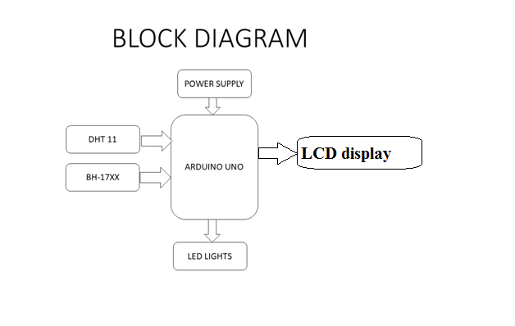

BLOCK DIAGRAM OF RECEIVER:

