https://www.youtube.com/watch?v=lgdPIbUNUTM
ADVANCED FOOTSTEP POWER GENERATION SYSTEM USING RFID FOR CHARGING

Day by day, the population of the country is increasing and the requirement of the power is also increasing. At the same time the wastage of energy is also increasing in many ways. So, reforming this energy back to usable form is the major solution. So, in this footstep power generation project, we are generating power with the help of human’s footsteps either by walking or running.
It uses the piezoelectric sensors. To generate a voltage from footstep the piezo sensors are mounted below the platform. To generate maximum output voltage the sensors are placed in such an arrangement. This is then forwarded to our monitoring circuitry. The circuit is the microcontroller based monitoring circuit that allows users to monitor the charges and voltage a connected battery to it and this power source has many applications. It also displays the charge generated by our footstep and displays on an LCD. Also, it consists of a USB mobile phone charging point where a user may it Connect cables to charge the mobile phone from the battery Charge. The current is distributed using (radio-frequency Identification) RFID cards so that only an authorized person can use the generator for charging. When the user shows the RFID tag it will read the microcontroller through RFID reader. Then the microcontroller switches on the relay at a particular duration of time for mobile charging. After complete the duration of time the microcontroller switches off the relay automatically. The voltage which is coming from piezo plates and time will display on LCD module.
The main controlling part of the whole system is Atmega328 Micro controller. In this project Piezo sensors, RFID reader and tags, LCD are interfaced to micro controller section. Micro controller reads the values from the piezo sensors. The energy from the sensors is stored by using battery, and it is helpful to charge the mobile.

Our project model cost is effective and Easy to implement and also it is green and not harmful to the environment. This system can be installed at homes, schools, colleges, where the people move around the clock. It can be used for charging devices e.g. laptop, mobile, etc.
The main aim of the project is to generate power from renewable energy sources; system makes use of Piezo. The system monitors the parameters coming from the piezo sensor, energy from piezo sensor values displayed on the LCD. The energy from the piezo sensors is used to charge the mobile.
A piezoelectric sensor is a device that uses the piezoelectric effect, to measure changes in pressure, acceleration, temperature, strain, or force by converting them to an electrical charge. The prefix piezo- is Greek for 'press' or 'squeeze'.

Major features of this project:
- Efficient and low cost design.
- Low power consumption.

Major blocks present in this system:
- Battery
- PIC Micro controller
- Piezo sensors
- Charging circuit
- Battery
- LCD display
- RFID module.
- LED indicator.
- Mobile charger.
Software’s used:
- PIC-C compiler for Embedded C programming.
- PIC kit 2 programmer for dumping code into Micro controller.
- Express SCH for Circuit design.

Regulated power supply:
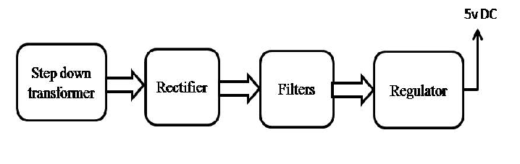
Block diagram:

