https://www.youtube.com/watch?v=gMy5RsGuoRQ
Double Acting Hack Saw Machine Operated by Scotch Yoke Mechanism

Increasing the productivity is one of the main requirements of production engineering in any kind of manufacturing industry. Either by reducing the operation time or by improving the capability of the machine to produce the components in an increased number at the same time is very essential for an industry to achieve the same. This project employs the Scotch yoke mechanism in power hacksaw machine which enables it to cut two components at a time thereby improving the productivity. In today world time a machine should be less time consuming. Power hacksaw cut one piece at one time so there was a loss in production rate. Double acting power hacksaw overcome this time-consuming problem. Power hacksaw is a fine-tooth power saw with blade held under tension in the frame. Double acting power hacksaw cuts two materials simultaneously by its scotch yoke mechanism, so the production rate increase twice then that of power hacksaw. Double acting power hacksaw works under by the scotch yoke mechanism. The scotch yoke mechanism converts the rotary motion into the reciprocating motion.
This project works on the scotch yoke mechanism. The scotch yoke mechanism converts the rotary motion into the reciprocating motion. The machine has the prime mover at the bottom of the machine. The pulley is attached to the body at the top and the end of the side portion. The pulley is connected with the disc type plate. The pulley and disc have separate connection with the one small metal rod through the bearing. The motor and pulley are connected with one V-type belt. The clamp is fixed with the disc. The clamp is fixed with the two shafts at the two ends. Each shaft is used for reciprocating motion. The hacksaw is connected to each shaft at the end. If the motor is turned ON, the pulley gets rotary motion, that rotary motion is converted to the reciprocating motion by the disc under the scotch yoke mechanism.

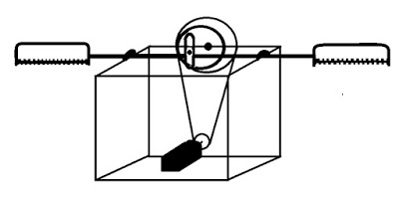
Double acting hack saw machine

