https://www.youtube.com/watch?v=lhzRW9sL0zA&t=21s
Secured Power Transmission with Over Load And Over Voltage Protection
This project proposes the innovative design to develop the system based on
Micro controller that is used for monitoring the voltage and current in a substation and to protect the system from the rise in mentioned parameters.
Providing the protection to the distribution transformer can be accomplished by shutting down the entire unit with the aid of the Radio frequency Communication. Moreover, the system displays the same on a displaying unit at the main station which is at a remote place. Furthermore, it is capable of recognizing the break downs caused due to overload and over voltage. The design generally consists of two units, one in the substation unit, called as transmitter and display unit, and another in the Main station called as controlling unit. The transmitter and the display units in the substation is where the voltage, current and temperature are monitored continuously by microcontroller and is displayed through the display unit.
An RF transmitter is used for transmitting the signals that are obtained. The controlling unit in the main station by means of a displaying unit and a RF receiver receives the RF signals that are transmitted by the Transmitter unit and reacts in accordance to the received signal. In general, the proposed design is developed for the user to easily recognize the distribution transformer that is suffered by any open or short circuit and rise in temperatures. The ultimate objective is to monitor the electrical parameters continuously and hence to guard the burning of distribution transformer or power transformer due to the constraints such as overload, input high voltage. If any of these values increases beyond the limit then the entire unit is shut down by the designed controlling unit.

Main objectives of this project:
- Monitoring the current and voltage in the distribution transformer.
- Protect the devices from over load and over voltage.
Major blocks of this project:
- Regulated power supply.
- PIC Micro controller.
- LCD display.
- Displaying unit.
- RF Transmitter.
- RF Receiver.
- Crystal Oscillator.
- Reset.
Software used:
- PIC-C compiler for Embedded C programming.
- PIC kit 2 programmer for dumping code into Micro controller.
- Express SCH for Circuit design.

Regulated power supply:

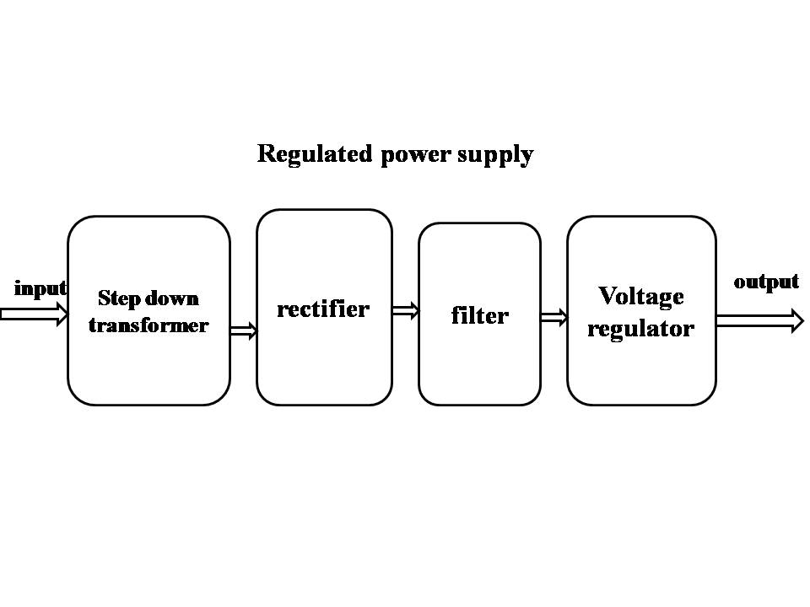

Block diagram:
